**COMP 3540 Advanced Web Design and Programming**

**Seminar/Lab 3.**

**Modal windows, and StarPage for TruQA**

1. **Learning outcomes**

* Centering
* How to display modal windows
* How to read user inputs and submit them
* ...

1. **Work to do – SignIn and Join**

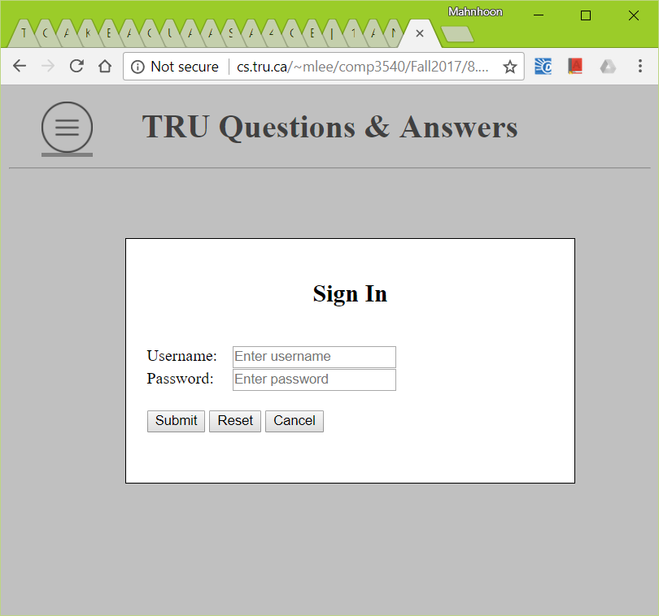 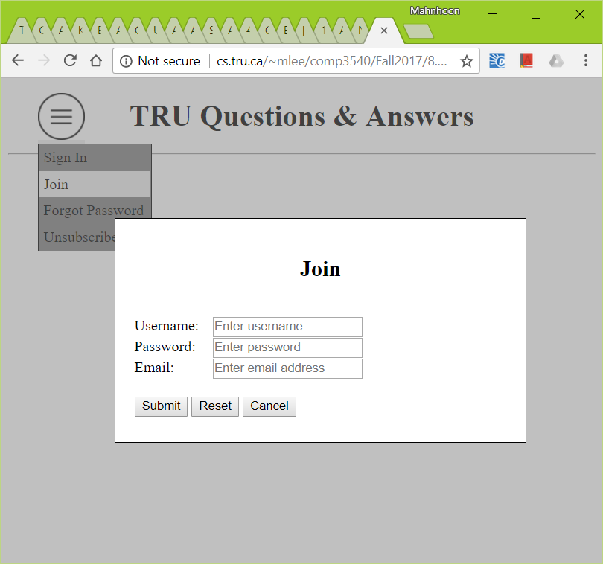

* + Considerations
    - Two web pages are used in TruQA – Start and Main.
    - They are generated using view_start.php and view_main.php, NOT html.
    - Both of the two web pages always send two pairs of ‘page’ value and ‘command’ value, with other values. E.g., {(“page”, “StartPage”), (“command”, “SignIn”)}.
    - The value of ‘page’ can be ‘StartPage’ and ‘MainPage’.
  + The above two modal windows SHOULD be displayed at the horizontal center, not like shown in the above. The titles in the modal windows also SHOULD be displayed at the horizontal center in the box.
  + You can start with the posted html file.
    - Blanket
* Initially it is not displayed.
* When ‘SignIn’ or ‘Join’ menu is clicked, it is displayed over all other content.
* When it is clicked, it should disappear.
  + - Modal windows for ‘SignIn’ and ‘Join’
* Initially they are not displayed.
* When ‘SignIn’ or ‘Join’ menu is clicked, it is displayed at the horizontal center and over all other content, including the above blanket.
* When the above blanket or ‘Cancel’ button is clicked, the modal windows and the blanket should disappear.
* The submit button is used to submit data to //cs.tru.ca/~mlee/comp3540/Software/test_display_inputs.php

1. **Assignment**

* For this week assignment, you just need to send me the URL of the above web application in cs.tru.ca, not the file, by email. Please include the course number in the email title so that I can easily classify the submitted assignments.
  + - * + The URL of the application in 2)

Due: 6:00 PM, January 26, 2018.

Any late submission will not be accepted.

Total marks: 10

* You should NOT use any one of the previous semester assignments.
* You should NOT update the application after you submitted. The information of any update of a file/directory will be left on CS, and I can check the last update date and time.
* The evaluation will be usually one of pass, half-pass, and fail. Most incomplete applications will get fail.